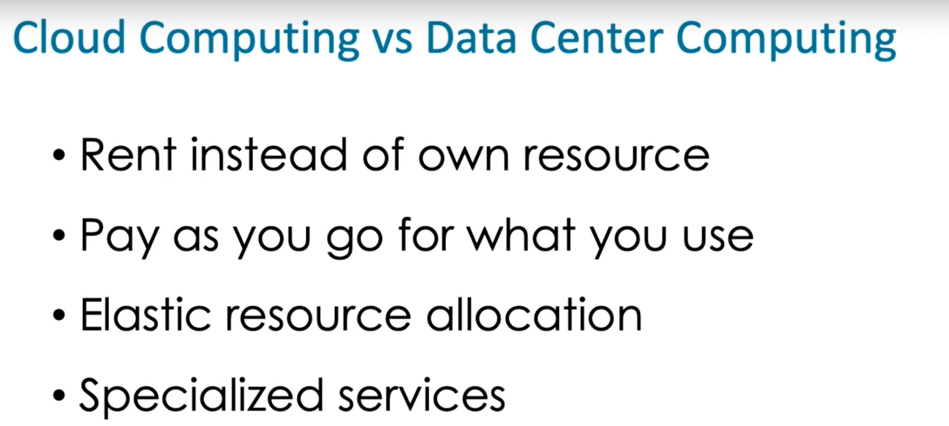

**GCP COMPUTING SERVICES :**

Compute engine , app engine , kubernetes engine , cloud functions - main services .

**Compute engine** : to create virtual machines .

**App engine** : app engine runs applications for us so we don't have to configure servers or other resources .

**Kubernetes engine** : Kubernetes is an orchestration platform.That means Kubernetes manages a cluster of machines and organizes how containers can run efficiently on the cluster. From the Kubernetes Engine page of the console, we can create clusters and run containers .

**Cloud Functions** is a service for running short event driven functions. These are useful if you want to run sub piece of code in response to a file uploaded to cloud storage,

or a message being written to a cloud pub sub topic. So when we create a cloud function, we specify a name, a memory to be allocated, the type of event that will trigger, the execution of the code, and then a listing of the code itself.

**GCP storage and database services :**

Nosql , relational , filesystem and object system .

**Nosql database :**

Big table (wide column database) ,

datastore (document databases) ,

firestore (document databases) .

**Relational database:**

Cloud sql - managed database service for running mysql and postgresql databases

Cloud spanner -Cloud Spanner is a horizontally scalable global relational database.

**Cloud File Store** is a managed **network file system**. This is useful when you need to store files persistently and share them across VM instances.

**Cloud Storage** is an **object storage system**. It organizes data into buckets. Now buckets can contain files, or objects, as well as folders. Cloud storage is useful for storing large amounts of unstructured data as well as archived files.

**NETWORKING WITH GCP :**

Networking in GCP is organized around virtual private clouds or VPCs. These are collections of subnets, instances and other resources we create in GPC.

VPC network peering and shared VPCs are ways of making resources in one project accessible to resources in another project.

We can create load balancers for distributing workload across instances. GCP has five kinds of load balancers. Three of them support global load balancing and two support regional load balancing.

Cloud DNS is a domain name service and Cloud CDN is a content distribution network for distributing static content around the globe.

We see hybrid connectivity. Virtual private networks are used to link on-premises data centers to the Google Cloud.

Interconnects are high bandwidth dedicated connections that are used when VPNs can't provide sufficient bandwidth.

**SPECIAL SERVICES IN GCP :**

Stackdriver for monitoring the performance of applications and instances.

Stackdriver Trace and Debug are useful for DevOps teams and developers.

Stackdriver Logging is a centralized logging service.

Cloud Build, for building containers,

Container Registry, for managing and sharing containers,

Deployment Manager, for deploying infrastructure and applications.

In the Big Data section, Dataproc, which is a managed Hadoop and Spark service,

BigQuery, an analytics database,

Dataflow, a stream and batch processing service based on Apache Beam,

Cloud Pub/Sub, which is a MessageQ service used to enable applications to share data

in an asynchronous manner.

Google also provides several specialized AI tools, including tools for vision and natural language processing.

gcloud projects describe followed by the PROJECT_ID or the PROJECT_NAME **to get metadata about a project**

When you create a project, you are automatically granted the roles/owner role. The owner role includes permissions granted by roles/editor, roles/viewer, and roles/browser.

Labels are key-value pairs attached to resources and used to manage them. The manager could use a key-value pair with the key 'team-name' and the value the name of the team that created the resource. Audit logs do not necessarily have the names of teams that own a resource. Traces are used for performance monitoring and analysis. IAM policies are used to control access to resources, not to track which team created them.

Cloud Audit Logs maintain three audit logs: Admin Activity logs, Data Access logs, and System Event logs. There is no such thing as a Policy Access log, a User Login log, or a Performance Metric log in GCP Audit Logs.

Constraints are the standard way to restrict where resources can be created and applying policies with constraints will enforce those constraints for all resources in the organization. If the policy were applied at the folder level, it would have to be applied for all folders and that is not as efficient as applying at the organization level